**Reserve**



**Tannat**

The grapes that give origin to this wine have been selected between the best parcels of our vineyard in Paso Cuello, Canelones, situated near the Atlantic Ocean, in the south of Uruguay. After a traditional fermentation where we looked for the maximum grape expressiveness, it was matured in French and American oak barrels during 12 months. The wine presents an intense and bright red color with violet shades. It aroma is complex and elegant with scents of ripe fruits, coffee and spices. In the mouth it is oily, enjoyable, with remarkable matured tannins. It accompanies strong plates with roasted red meats and of hunting, lamb, mature cheeses and stews. Serving temperature: 18-20 ºC.

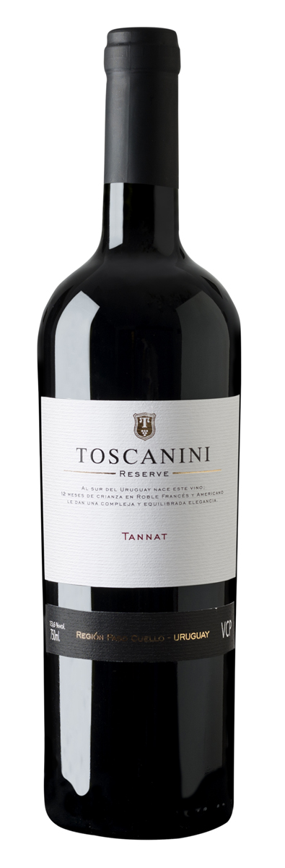

**DATE**

Region: Paso Cuello, Uruguay.

Climate: Tempered and maritime, with good influence of Atlántic Ocean

Type of soil: Frank clayer, calcareous, with good permeability.

Type of grapes: Tannat100%

Type of harvest: Manual.

Crushing: soft 80% of the grains. The rest as whole grain

Alcoholic fermentation: 12 days at 26-28º C.

Malolactic fermentation: Spontaneous.

Oak aging: 12 month in French and Américan Oak.

Alcohol: 13,9 %

Total acidity: 3,1 g/l

Residual sugar: 1,8 g/l

pH: 3,81

**TECHNICAL DATE**

Type of bottle: Heritage 750ml. - olive green

Code: EAN 13 – 7730900340168

Closure: Cork

Full bottle weight: 1,400kg

**PACKAGING**

6 bottle box: cardboard

Code: DUN 14-17730900340165

Dimensions: (L x W x H): 240 x 162 x 338 (mm)

Full weight: 9,200kg